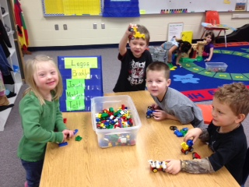

Elkton Preschool
Our Preschool program is based on the philosophy that young children learn best through their play and activity based experiences. Through the planned activities and experiences in Preschool, children learn about the ABC’s and 123’s and even more importantly, they develop their social and emotional skills. Developing strong social/emotional skills will benefit children both academically and socially throughout their lives. Preschool is a wonderful place for children to develop many skills through playful activities. We have a lot of fun in Preschool!

Junior Kindergarten
Jr. Kindergarten provides a good transition between Preschool and Kindergarten for children who need an additional year to grow and mature before beginning the more formal side of school. Children need to be five years old by September 1st to be in Jr. Kindergarten.
Jr. Kindergarten students come five half days each week. If you would like more information about Jr. Kindergarten, please contact Mrs. Fargen at the school.

