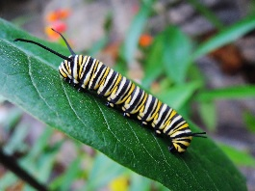 |  |  | August  Preschool/Jr. Kind. Mrs. Fargen  School: 542-2541 ext.219 Home: 542-2048  Email-Vickie.Fargen@k12.sd.us |  |  |  |  | 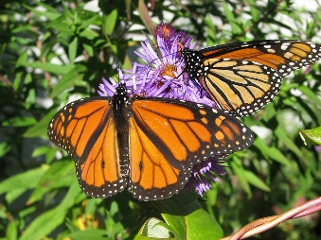
Sunday | Monday |  |  | Tuesday | Wednesday | Thursday | Friday |  | Saturday
 |  |  |  | Happy  Birthday!  Jadin  August 1st | Happy  Birthday!  Kennedy  August 6th | Happy  Birthday!  Emma  August 24th
13 | 14 |  |  | 15 | 16 | 17 | 18 |  | 19
A.M. Class
8:15-11:00
P.M. Class
12:45-3:30
20 | Preschool 21 |  |  | Preschool 22 | 23 | Preschool 24 | Preschool 25 |  | 26
Themes:  BUGS/SCHOOL  Learning about Insects &  School | First Day  of  Preschool/  Jr. Kindergarten  Picture  Day |  |  |  | Snack Helpers | Preschool/  Jr.Kind.  Parent Meeting  7:00 pm  AM-Emma  PM-Jadin | Library  Day  AM- Brazen  PM-Harper
27 | Preschool 28 |  |  | Preschool29 | 30 | 31 | Sept. 1
Snack Helpers | AM-Abel  PM-Joshua |  |  | AM-Codi  PM-Alexa | Jr. Kind. PM  12:00-2:15 | AM-Jas K.  PM-Adeline | No  School

